Vision Statement: To see a world where every person comes to know the Lord Jesus as their personal Saviour.

Mission Statement: To be a soul-winning group of believers, founded on Jesus Christ. To live as lights in our community, showing love and equipping believers for a life of serving Christ.
Thank you for your weekly tithes and offerings in the box at the back. “So let each one give as he purposes in his heart, not grudgingly or of necessity; for God loves a cheerful giver.”
2 Corinthians 9:7
Questions/suggestions also welcome.
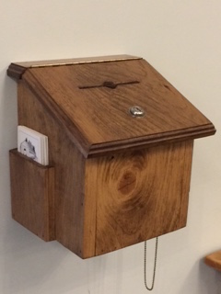
SERMON NOTES

_______________________________________________________________________
Please email Phebe at phebenian@gmail.com or contact Pastor Rick or one of the Deacons if you have any Prayer or Praise items or updates for the bulletin.
Pastor Rick Crockford Home: 705-746-9893
Fellowship Baptist Church
138 William Street, Parry Sound, ON, P2A 1W2
(705) 746-5154
fbc@vianet.ca www.fbcparrysound.com
FELLOWSHIP
BAPTIST CHURCH

Founded on the Rock:
Preaching the Gospel truth; Equipping for Life
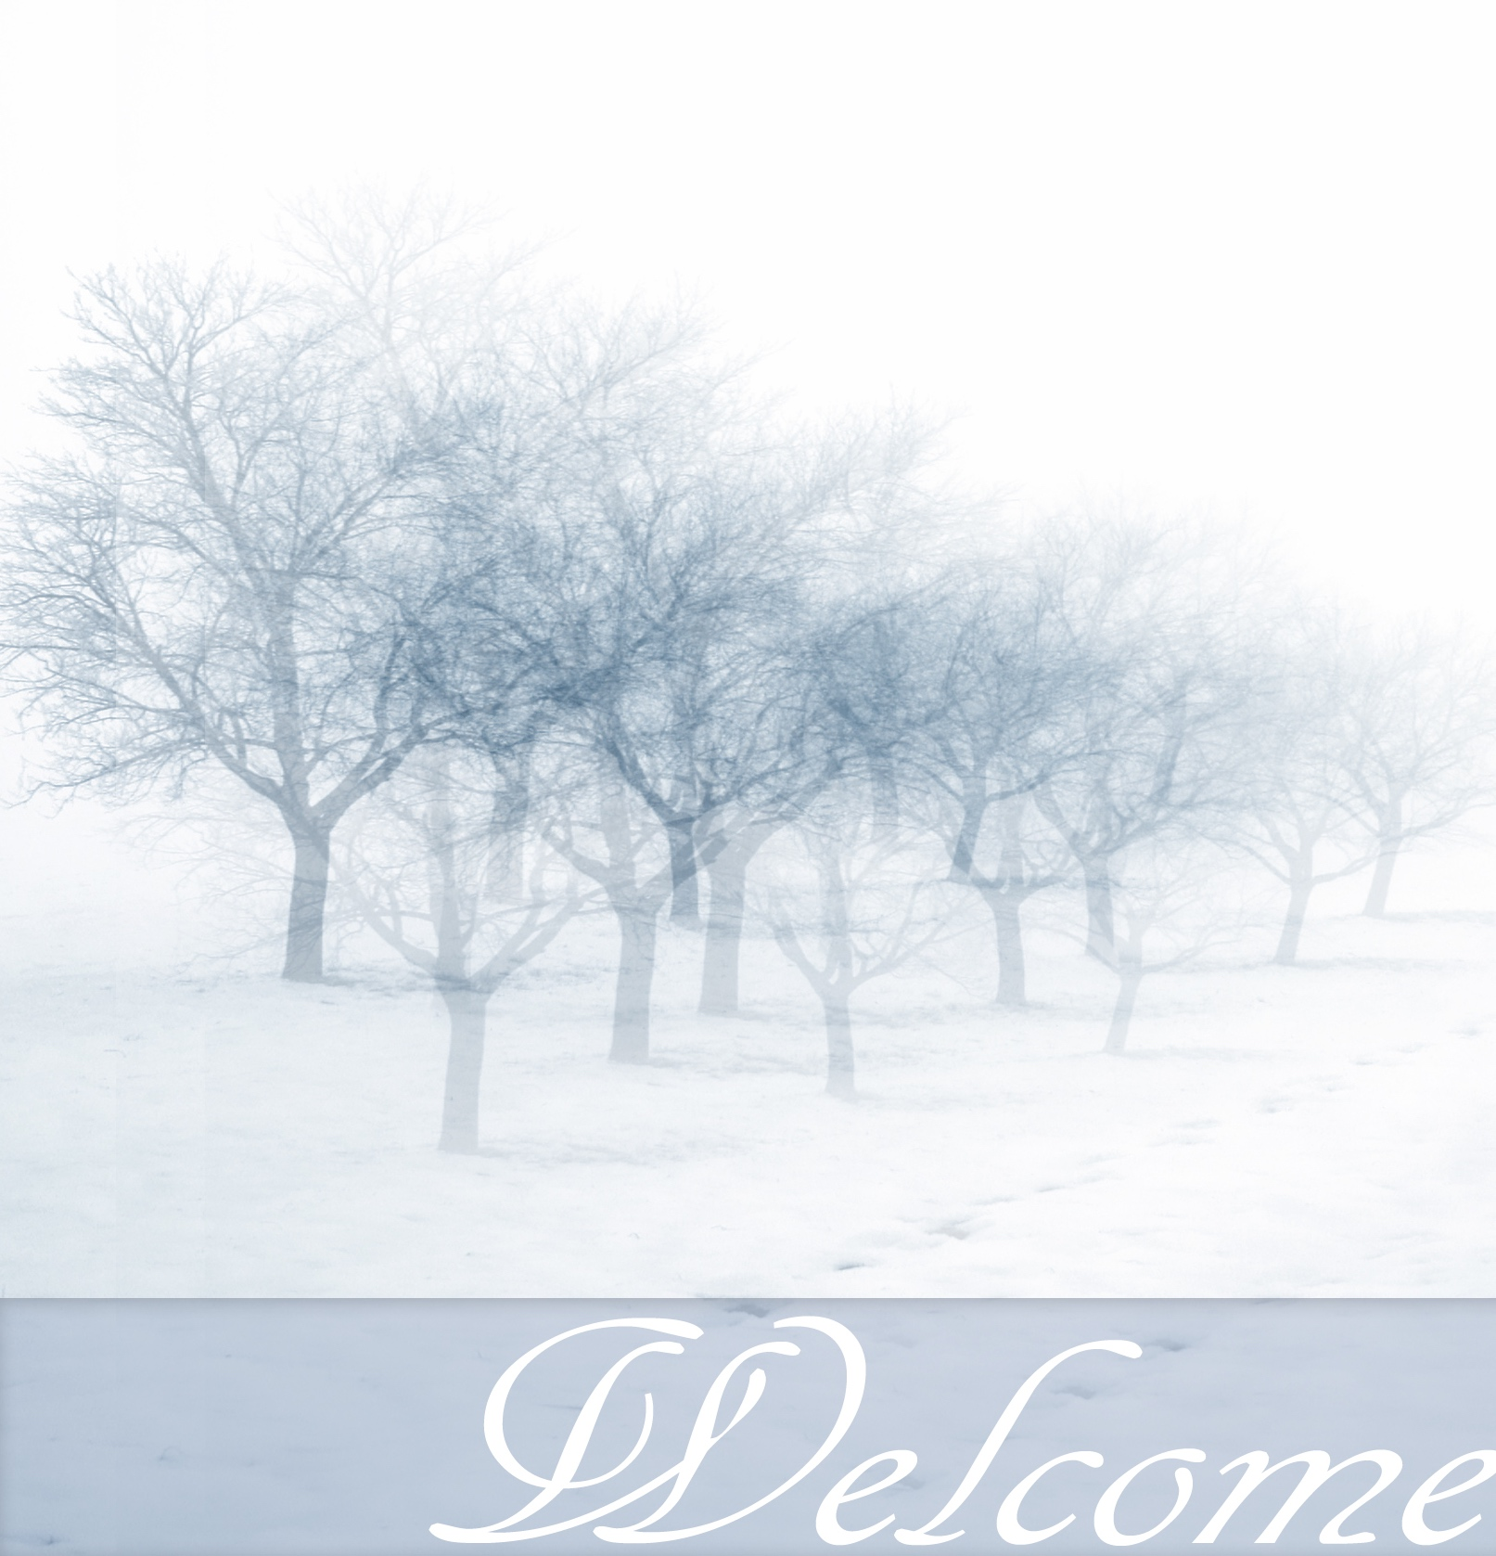

Therefore He is also able to save to the uttermost
those who come to God through Him,
since He always lives to make intercession for them.
Hebrews 7:25

February 18, 2018

FELLOWSHIP BAPTIST CHURCH

Welcome To:

9:30 Adult Bible Class – the book of Genesis
TODAY’S SERVICES
February 18th, 2018

10:50-11:00 Quiet Meditation to prepare our hearts for worship
Welcome and Prayer
Call to Worship: Hebrews 1:6-9
Hymn: #4 Praise The Saviour
Hymn: #56 To God Be The Glory
Hymn: Once Again
Memory Verse of the Month: 2 Timothy 1:12b I am not ashamed, for I know whom I have believed and am persuaded that He is able to keep what I have committed to Him until that Day.

Announcements
Scripture Reading: 1 Chronicles 18:6-8, 14
Hymn: #9 Glorify Thy Name
Children’s Song: Deep And Wide
Children’s Story and Dismissal to Junior Church
Sermon- Pastor Rick:
“God Preserves”

Hymn: #21 O For A Thousand Tongues To Sing

Tonight: Power Time Prayer Chapel 6pm,
Eve. Service 6:30pm
THIS WEEK AT FELLOWSHIP:
MONDAY | 10 am  6 pm | Ladies’ Bible Study  AWANA
TUESDAY
WEDNESDAY | 7:30pm | Men’s Bible Study at FBC
THURSDAY | 7 pm | Music Practice
FRIDAY
SATURDAY
Upcoming: Business Meeting Tuesday Feb. 27, 2018, 7:30pm
PRAYER
Pray for salvation for family members of our congregation. For Alice Brandon with adrenalitis from influenza, Marie and Andy’s neighbours’ newborn son in Mount Sinai, Richard and Marie’s great-nephew who is severely ill in hospital, for Cathy’s friend Jess with cancer, for Tricia McEwen, going through personal struggles; Lorena re: getting through the winter then moving in May to Niagara to help her daughter, and re: her brother Ken with cancer for salvation and help. Praise for the AWANA program. If you have questions about your need for salvation from sin and hell, and what Jesus is offering you, please speak to any of the leadership and we would be happy to help you.
Pray for our Missionaries!
Thorntons –for children saved at camp, for their ongoing encouragement, upcoming Game Dinner in April
Lees –for Grassy Narrows people for salvation and for help re: mercury toxicity, addictions, poverty. For the 10 children that attend weekly.
Midigos –in Goma, DRC. Dangerous and violent re: upcoming elections. Having to stay inside and locals come to them for training/meetings. Government closed all communications including cell phones and internet. Financial and prayer support needed for programs. Pray for safety and for peace, and for solution for the spread of cholera in Goma and famine throughout DRC.
Butlers ––PNG, mission work, safety on the rivers. Back at work in PNG doing technical support for inland missionaries.
Brandons –coming to see us in the Spring! Cameroon Biblical Seminary – had 8 Christian leaders from 3 African countries attend for training, African professors now starting to be able to teach courses missionaries used to teach

