Sermon Notes:

_______________________________________________________________________
Please email Phebe at phebenian@gmail.com or contact Pastor Rick or one of the Deacons if you have any Prayer or Praise items or updates for the bulletin.
Pastor Rick Crockford Home: 705-746-9893
Fellowship Baptist Church
138 William Street, Parry Sound, ON, P2A 1W2
(705) 746-5154
fbc@vianet.ca
www.fbcparrysound.com
FELLOWSHIP
BAPTIST CHURCH

Founded on the Rock:
Preaching the Gospel truth; Equipping for Life
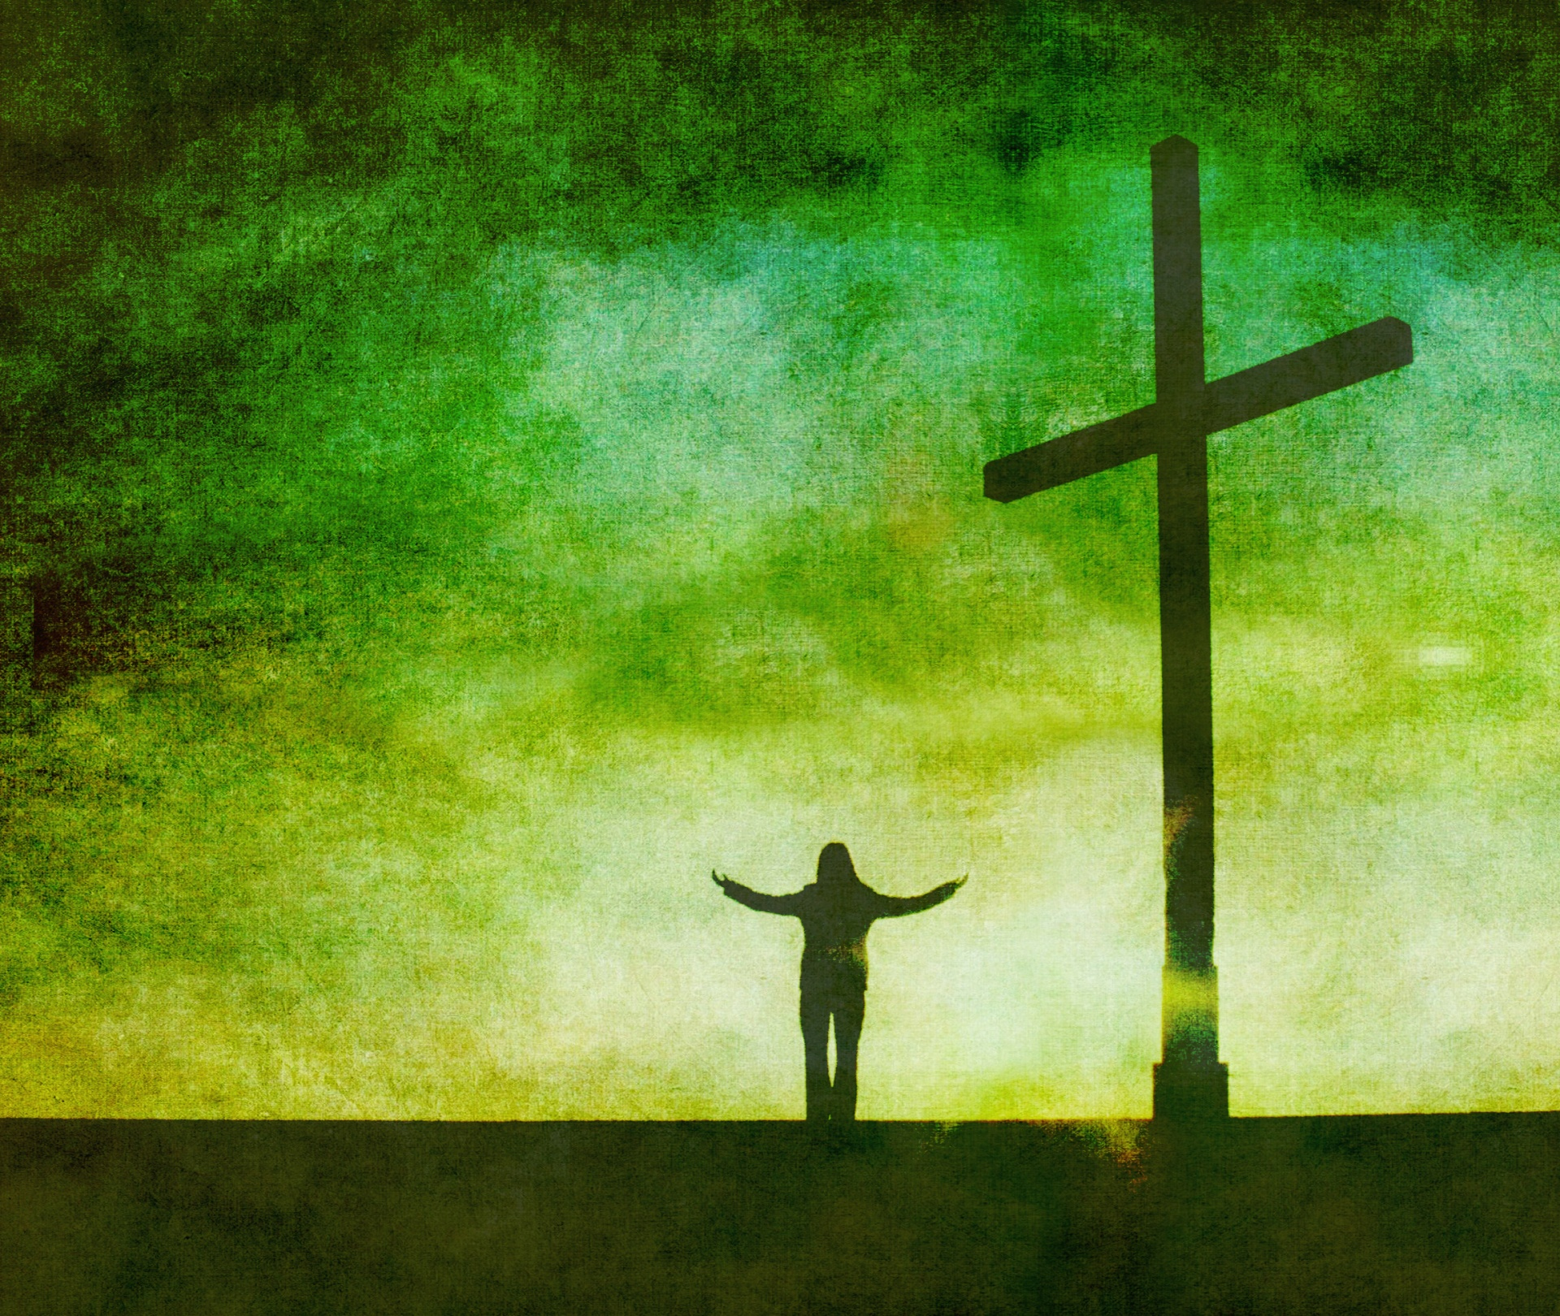

He who believes in Him is not condemned;
but he who does not believe is condemned already,
because he has not believed in the name
of the only begotten Son of God.
John 3:18

Welcome!
November 5, 2017

FELLOWSHIP BAPTIST CHURCH

Welcome To:

9:30 Adult Bible Class – the book of Revelation.
TODAY’S SERVICES
November 5, 2017

10:50-11:00 Quiet Meditation to prepare our hearts for worship
Welcome and Prayer
Call to Worship: 2 Samuel 22:36, 37
Hymn: #91 In Moments Like These
Hymn: #510 Heaven Came Down
Hymn: #173 I’m Forever Grateful

Memory Verse of the Month: John 16:33
These things I have spoken to you, that in Me you may have peace. In the world you will have tribulation; but be of good cheer, I have overcome the world.

Announcements
Scripture Reading: John 1:29-34
Video Song: Good, Good Father (Chris Tomlin)
Hymn: Amazing Grace (My Chains Are Gone)
Children’s Song: I Am A C-H-R-I-S-T-I-A-N
Children’s Story and Dismissal to Junior Church
Sermon- Pastor Rick:
“Christ Alone”
Hymn: #318 I Believe In A Hill Called Mount Calvary
Communion
Tonight: Power Time Prayer Chapel 6pm
Evening Service 6:30pm

THIS WEEK AT FELLOWSHIP:
MONDAY | 10 am | Ladies Bible Study
TUESDAY | 10 am  10:30 | The Knitting Circle at FBC  Fellowship at The Gardens
WEDNESDAY | 8:30am  7:30pm | Men’s Breakfast at Trappers  Men’s Bible Study at FBC
THURSDAY | 7 pm | Music Practice
FRIDAY
SATURDAY
Shoeboxes! If you forgot to return your shoebox today, you can still return them this week to St. Andrews Presbyterian
Business Meeting – November 21, 7pm
Christmas Parade- November 25- please pitch in and help in the morning, and join us for a ride or walk in the parade in the afternoon. Talk to Pastor Rick if you can help ahead of time.
PRAYER
Praise that Andy & Marie’s son Chris has been healed.
Thank you for praying through the week! Pray for the possibility of an AWANA program. Please continue to pray for health those in our congregation, and for the salvation of any who haven’t yet accepted Jesus as their personal Savior. If you have questions about your need for salvation from sin and hell, and what Jesus is offering you, please speak to any of the leadership and we would be happy to help you.

Pray for our Missionaries!
Thorntons –praise for children saved at camp
Lees –for the people of Grassy Narrows, daughter Grace –received scholarship for Masters program in the Fall, but still needs funds for the rest; praise for mission team doing VBS
Midigos –in Goma, DRC, need support for food and small business programs for women. Pray for safety and for peace, and for solution for the spread of cholera in Goma and famine throughout DRC.
Butlers ––PNG, mission work, safety on the rivers. Back at work in PNG doing technical support for inland missionaries.
Brandons –new update and prayer requests re: local pastor teaching conferences in Cameroon

